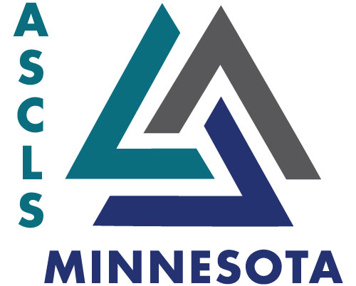
ASCLS-Minnesota
2021 Spring Board Meeting
Sunday, April 11, 2021
6:00 – 8:00 pm
Zoom Call

Minutes:

- Call to Order and Introductions: Wendy Parpart Call to order at 1802

- Review previous meeting minutes: Wendy Parpart Motion to approve previous board meetings: motioned by Dean Porter, second by Donna Spannaus-Martin

- Secretary’s Report: Crystal Paul

- Treasurer’s Report and Budget Report, Finance Committee:

  - Jenna Amundson
  - Finance report – Treasurers report – Checking account $21,491, Scholarship Fund will have an increase after the CLC contributions
CLC $7,123
  - Rick talked about the budget – Finance committee met earlier last week
  - Budget to provide some financial support – it doesn’t cover everything, but covers some for our president, president elect and president elect elect to go.
  - In columbns D & E, we’re budgeting for this summer
  - The budget going forward is for our JAM events being hybrid going forward
  - Leg day is being moved from March to October
    - We typically fund President Elect and Government Affairs Liaison and the Student
  - We’ve received 2 payments thus far from national dues, but we’re expecting 2 more. We lowered the budget expectation from national due to our lowered membership
  - Motion to approve budget 2021/2022: Donna Showers moves – Jenna seconds
    - Budget passes at 1830

- Financial Working Group –Rick Panning
- CVENT – Charlotte Romaine
- ASCLS-MN Web Site and Newsletter
    - Jenna- Web Site – No updates
    - Newsletter- Dani Ashcroft – waiting until after CLC to start the next newsletter – please send any ideas and updates to her

Membership Development –Dean Porter – we increased by 20 members this year

Leadership Development – Karen Renaud – No report

Region V Leadership Academy - Crystal Paul – Deadline updated to August 1st

Region V and National Update – Jean Bauer – Registration for JAM is open (hotel and meeting itself) held as a hybrid. Monthly directors checkin call – HOD was discussed; trying to establish how to do a hybrid HOD but currently the delegates should plan to be in Louisville; in person. Regional caucuses will occur prior to the JAM; in June prior to Louisville.
Region V symposium October 7th and 8th – Steph Jacobson is chair and each state has provided some representatives to help plan the meeting.
2022’s Region V in MN, 2023 Region V is planning to be held in WI (very exciting!)
Lab Week – DAC is planning a panel an informal panel on diversity topics. They will plan the new book for the bookclub for this coming year.
There will be a town hall on licensure that will include a panel of people on it.
One of the big things – (no commitments to anything at this point; input only) looking at eliminating regions (particularly the region directors). This would allow for other constituent societies to work together for other socieits. The dollars held in the treasury for the regions would go back to the states. This is ultimately to change the governance structure to help ASCLS move forward for the better and for the future. Looking for feedback and initial thoughts. It helps provide not just a representative from each region, but people who truly want to be on the board. More formal presentation to follow at the region caucus.

Area Director’s Report
- SE Area – Brenda Tomanek Rebecca Beckmann no report
- SW Area – Rita Miller Not on
- NW /Central Area – Danielle Ashcroft No report
- NE Area – OPEN
- Metro Area-Galina Dronova, Tori Contreras Not on

- Ascending Professional Chair- Eykka Gundlach No report
  - Developing Professional –Kristyn Carson

.
Clinical Laboratory Collaborative Updates –Crystal Paul
2021 CLC held virtually

Government Affairs and Political Action Committees- Donna Showers
Advocacy on linked in – comes from ASCP – state licensure law change about the state of Tennessee

Delegates for Annual Meeting:
- 4/ 2 alternates – Need to vote on 4 with 2 alternatives – Will have to do a poll for these
- On site
Education Committee/Scholarship – Lorna Ruskin

Awards and Nominations: Sue Iddings
Key to the future
Newsletter/webmaster
Sue nominated Jenna as a delegate for JAM

Scientific Assembly –
- Scientific Assembly Group Chair – Jeremy Angell
- Laboratory Admin/Consulting/QA/Accreditation/Industry – Sue Iddings
- Microbiology/Public Health – Kristy Connors
- Education – Lorna Ruskin
- Chemistry/Urinalysis – Kenneth Buesgens
- Hematology/Coagulation –
- Immuno/Immunohematology – Renee Burke
- Phlebotomy – Jeremy Angell
- Molecular Diagnostics – Charlotte Romain

New Business:

Meeting Adjourn
Motion to adjourn at 1926 by Donna, Dan seconds . Meeting adjourns at 1927

Respectfully submitted,
Crystal Paul

